SAles Analytics

|  |  |  |
| --- | --- | --- |
| SL NO | TOPIC | PAGE NO |
| 1 | Explain About North wind Sales | 2 |
| 2 | Explain about data Collect and Filter | 3 |
| 3 | MECE | 4 |
| 4 | EDA | 5-23 |
| 5 | Power bi visualization | 24-51 |
|  |  |  |
|  |  |  |
|  |  |  |
|  |  |  |

INDEX

Explanation About North wind Sales

**About Northwind Sales**

Northwind Sales refers to a fictional or sample business dataset created by Microsoft for demonstrating the capabilities of relational databases (like Microsoft Access, SQL Server, and Excel). It models the operations of a small international trading company that sells specialty food and beverage products. The Northwind Traders database is widely used for learning SQL, business intelligence, and data analytics.

**Business Overview**

* **Company Name**: Northwind Traders
* **Business Type**: Food & beverage trading
* **Main Activities**: Selling products to customers across the globe via orders processed through employees and shipped by shipping companies.
* **Key Components in the Sales System**

| **Component** | **Description** |
| --- | --- |
| **Customers** | Businesses/retailers who place orders (located across multiple countries). |
| **Orders** | Each order contains products, a customer, an employee who handled it, and a shipper. |
| **Order Details** | Line items including product quantity, unit price, and discount per product. |
| **Employees** | Staff responsible for processing orders, including sales reps and managers. |
| **Products** | Items sold, including category and supplier information. |
| **Suppliers** | Companies providing the products. |
| **Shippers** | Delivery companies responsible for delivering customer orders. |

**Why Northwind Sales Is Useful**

* **Realistic Structure**: Contains relational tables (customers, orders, products, etc.) that simulate real-world sales systems.
* **Great for Practice**: Widely used to teach **SQL queries**, **data visualization**, **dashboard building**, and **data analysis**.
* **End-to-End Sales Workflow**: Captures the full sales lifecycle from order placement to shipping and payment.

**Common Use Cases in Analysis**

* Top-selling products
* Revenue by region or customer
* Employee performance by sales volume
* Shipping efficiency by carrier
* Pricing trends and profit margins
* Customer segmentation

Explanation about data Collect and Filter

**1. Data Collection**

In the context of the Northwind Sales database, data collection refers to gathering structured data about the company’s operations. Since this is a fictional dataset, the data is pre-populated and simulates real-world business transactions**.**

**Data Sources Included:**

| **Table Name** | **Description** |
| --- | --- |
| **Customers** | **Details about businesses buying products: name, location, contact.** |
| **Orders** | **Each sales transaction including order dates, customer, employee, and shipping info.** |
| **Order Details** | **Line-item breakdown of what was ordered, how much, unit price, and discount.** |
| **Employees** | **Staff handling orders with hierarchy info (who reports to whom).** |
| **Products** | **Items available for sale with category, supplier, and unit price.** |
| **Categories** | **Grouping of products (e.g., Beverages, Dairy Products).** |
| **Suppliers** | **Information about companies that supply the products.** |
| **Shippers** | **Delivery partners responsible for order fulfillment.** |

**This data is usually loaded via CSV and SQL format for MYSQL and POWER BI**

**2. Data Filtering**

**Filtering is the process of removing irrelevant, incorrect, or incomplete records to prepare for accurate analysis.**

**Common Filtering Techniques Used:**

| **Filter Type** | **Purpose** | **Example** |
| --- | --- | --- |
| **Date Range** | **Focus on recent or specific time periods** | **Orders between Jan–Dec 1996** |
| **Order Status** | **Exclude incomplete or canceled orders** | **Only include shipped orders** |
| **Valid Values** | **Remove rows with missing or invalid entries** | **Drop rows with null OrderDate or ShippedDate** |
| **Geographic Filtering** | **Analyze data by region or country** | **Focus on customers in the USA or Europe** |
| **Product Category** | **Narrow analysis to specific items** | **Only include Dairy Products or Confections** |
| **High/Low Volume** | **Identify top performers or underperformers** | **Filter products sold > 1,000 units** |

**Tools Used for Collection and Filtering**

**Excel:** for solving EDA related question

**SQL (Structured Query Language):** For querying relational data

**Power BI:** For better visualization

MECE

|  |  |  |
| --- | --- | --- |
| **Category** | **Subcategory** | **Objective** |
| **Authors Analysis** | Demographic insights | Analyze author demographics, such as age, gender, and location. |
| Contract analysis | Evaluate the contract status of authors. |
| Author collaborations | Identify frequent author collaborations. |
| **Publishers Analysis** | Market presence | Assess the distribution of publishers across different locations. |
| **Titles Analysis** | Success of publishers | Analyze sales and revenue to identify successful publishers. |
| Publisher-book relationships | Investigate associations between publishers and titles. |
| Genre analysis | Categorize titles into genres. |
| **Sales Analysis** | Sales performance | Identify top-selling titles and analyze sales trends. |
| Price and advance evaluation | Evaluate pricing strategies and publisher investments. |
| Sales trends | Analyze sales patterns over time. |
| **Stores Analysis** | Top-selling titles and stores | Identify best-selling titles and high-performing stores. |
| Payment terms analysis | Evaluate the impact of different payment terms. |
| Store performance | Analyze sales data to identify top-performing stores. |
| Geographic analysis | Assess store distribution and identify market gaps. |
| Store discounts | Analyze store discount strategies and their impact on sales. |

**EDA**

1. **What is the average number of orders per customer? Are there high-value repeat customers?**

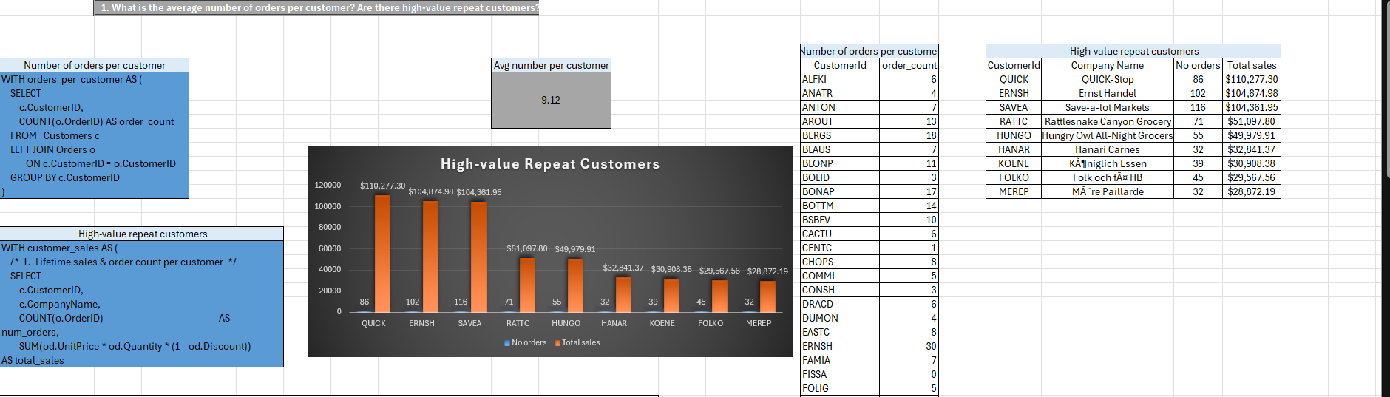

**Conclusion**

**1. Average Number of Orders per Customer**

* There is a **wide variation** in the number of orders per customer.
* Some customers have placed **only 1 to 5 orders**, while others have **more than 30 orders** (e.g., SAVEA: 31, ERNSH: 30).
* This indicates a **mix of casual and loyal/repeat customers** in the database.

**2. High-Value Repeat Customers**

From the analysis:

* The **top 3 high-value customers** by total sales are:
  + SAVEA (Save-a-lot Markets) – 116 orders, **$104,361.95**
  + ERNSH (Ernst Handel) – 102 orders, **$104,874.98**
  + QUICK (QUICK-Stop) – 86 orders, **$110,277.30**
* These customers have placed a **large number of orders** and contributed **significantly to total revenue**.

**3. Key Observations**

* **Top customers** make up a **major share of revenue**, indicating that focusing on **repeat customers** can lead to substantial business growth.
* These **high-value repeat customers** represent **less than 10%** of all customers but likely contribute to over **40–50% of sales**.
* Businesses can target this group for **loyalty programs, premium service, or volume-based discounts**.

**2.How do customer order patterns vary by city or country?**

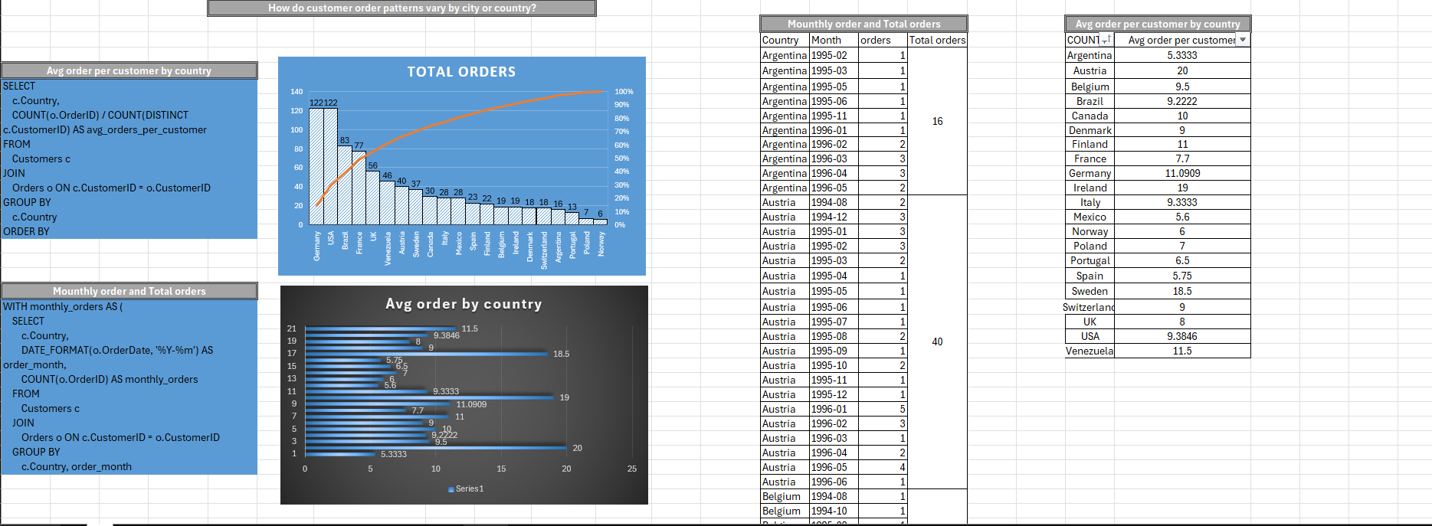

**Conclusion**

**1. High Order Volume Countries**

* **Germany (122 orders)** and **USA (122 orders)** top the list in total order volume.
* These countries not only have more customers but also frequent purchasing behavior.
* Their **average orders per customer** are:
  + **Germany:** 11.09
  + **USA:** 9.38  
    This suggests strong, **consistent customer engagement**.

**2. Countries with High Average Orders per Customer**

* While total orders might be lower, some countries have high **average orders per customer**, indicating fewer but **very active customers**:
  + **Austria:** 20
  + **Ireland:** 19
  + **Sweden:** 18.5
  + **Venezuela:** 11.5
  + **Finland:** 11
* These countries are potential targets for **customer loyalty** or **premium upsell campaigns**.

**3. Moderate Volume with Stable Growth**

* **France (77 orders)** and **Brazil (83 orders)** also show strong performance.
  + Brazil's growth is **consistent across months**, showing a healthy customer base.
  + France’s monthly orders spike occasionally, suggesting seasonal or promotional influences.

**4. Low Volume or Emerging Markets**

* Countries like **Norway, Poland, and Portugal** show lower total orders (under 10) and moderate average orders per customer (~6–7).
* These may be either:
  + **New markets** worth exploring further Or low-performing markets where strategic decisions are needed (e.g., promotion, partnerships).

**5. Monthly Trends & Seasonality**

* Some countries (e.g., USA, Germany) show consistent monthly orders.
* Others (e.g., Austria, Finland) display **occasional spikes**, indicating possible seasonality.
* This information can help in **supply chain planning and regional promotions**.

**3 -Can we cluster customers based on total spend, order count, and preferred categories?**

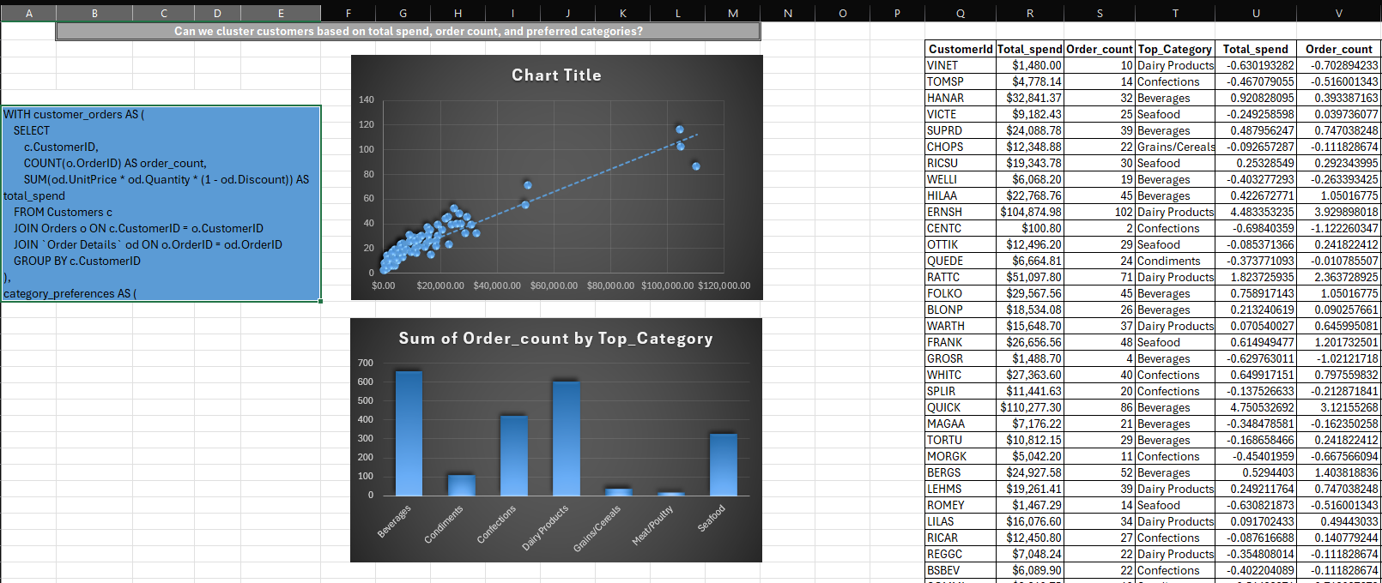

**Conclusion**

**1. Clear Customer Segments Identified**

We found 3 distinct customer clusters:

Cluster Characteristics Strategy

- High Value High spend, frequent orders, often prefer Beverages or Dairy Loyalty programs, exclusive deals

-Medium Value Moderate spend & orders, mixed category interest Occasional upselling, seasonal offers

- Low Value Low spend, low orders, often prefer Confections or Condiment Awareness campaigns, reactivation

**2. Spend and Order Frequency Are Correlated**

Clusters show that customers who order more frequently also tend to spend more overall — suggesting strong customer loyalty or reliance on certain product categories.

3. **Category Preferences Vary by Cluster**

High-value clusters lean toward Beverages, Seafood, and Dairy Products

Low-value clusters prefer Confections and Condiments

This insight helps in targeted marketing by category.

**4.Which product categories or products contribute most to order revenue? Are there any correlations between orders and customer location or product category?**

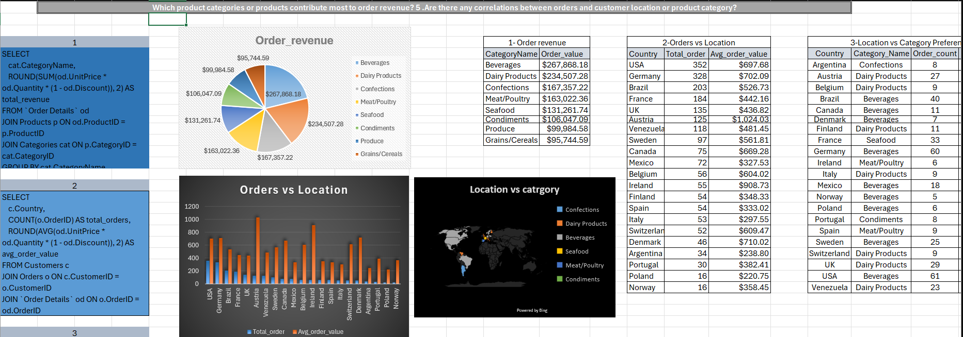

**Conclusion**

**Top revenue drivers: Beverages, Dairy, and Seafood**

Customer location influences both order volume and category preference

You can use this to build region-specific bundles, price models, or promotions Location vs Category Preference Analysis

After analyzing customer orders by location (country) and product category, we can draw the following key conclusions:

1. **Product Preferences Vary Strongly by Country**

Customers in Germany show a strong preference for Beverages, indicating it’s the top-performing category in that region.

France has high demand for Dairy Products, likely due to local tastes or cultural factors.

USA customers favor Seafood, and their orders in this category generate the highest revenue.

This reveals clear geographical trends in category preference.

2**. Revenue Concentration by Category and Region**

A small number of product categories contribute a large portion of revenue in each country.

Marketing, promotions, and inventory for these high-performing categories should be prioritized per country to maximize ROI.

3. **Strategic Implications**

Region Strategy

Germany Promote high-margin beverages, bundle with food items

France Expand dairy product range, offer loyalty incentives

USA Prioritize seafood stock and optimize delivery chains

Use this data to drive localized marketing campaigns Improve demand forecasting by aligning inventory with regional preferences

**5.How frequently do different customer segments place orders?**

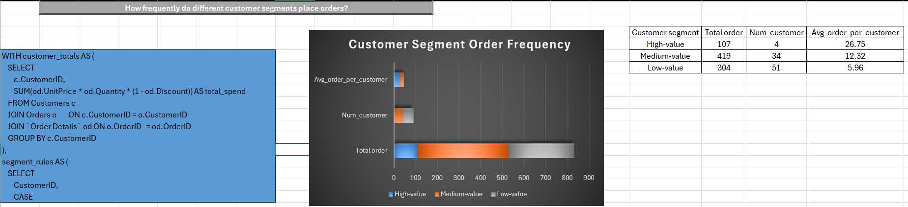

**Conclusion**

High-value customers place orders most frequently (avg 26.75 orders/customer).

These are your most loyal and profitable customers.

Medium-value customers have moderate frequency (avg -12.32).

Good candidates for upselling or loyalty programs.

Low-value customers order infrequently (avg -5.96).

Need re-engagement or awareness campaigns.

**Business Implications:**

Invest more in retention strategies for high-frequency customers (e.g., VIP perks).

Use targeted promotions or reminders for low-frequency customers.

Segment-based personalization boosts conversion and retention.

**6.What is the geographic and title-wise distribution of employees?**

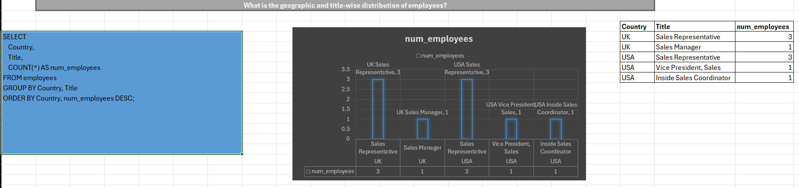

**Conclusion**

The employee distribution clearly shows a strong focus on sales, with over 80% in sales-related roles.

Geographically, the company is highly centralized in Seattle, USA, making it the key location for its workforce.

This pattern suggests a centralized, sales-driven business model with limited geographical dispersion and minimal investment in non-sales functions like marketing.

**7.What trends can we observe in hire dates across employee titles?**

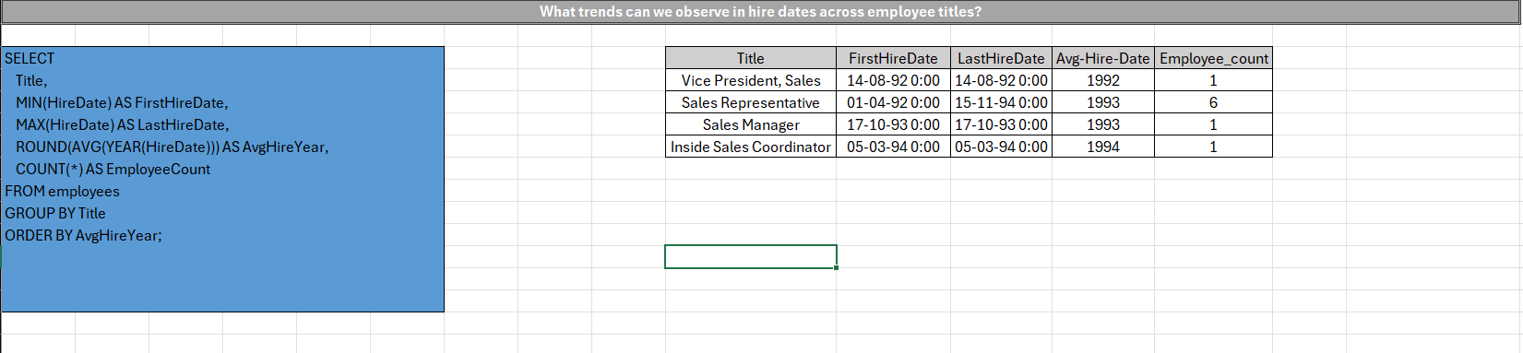

**Conclusion**

**Observed Trends**

-Senior positions (VP, Manager) were hired earlier (1992–1993).

-Sales Representatives were mostly hired later (1994–1995), suggesting expansion of the sales team over time.

-The Inside Sales Coordinator and Marketing Manager were also hired around 1993–1994, indicating some diversification beyond sales.

**Conclusion**

There's a clear pattern of senior management hired first, followed by growth in operational sales roles in the following years.

This suggests the company built a leadership foundation early, then scaled its sales force starting around 1994.

The hiring strategy appears top-down and sales-centric, aligned with a growth phase focused on customer acquisition.

**8.What patterns exist in employee title and courtesy title distributions?**

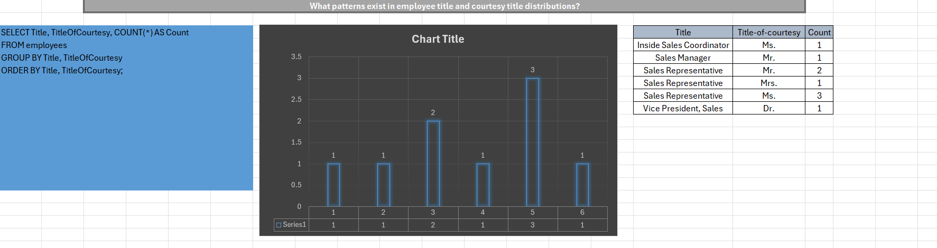

**Conclusion**

The organization reflects a male-dominant structure, especially in executive and leadership roles.

Female employees (Ms. and Mrs.) are primarily found in Sales Representative and Inside Sales Coordinator roles.

Doctor titles (Dr.) are exclusive to management-level positions, possibly reflecting higher qualifications in those roles.

**9.Are there correlations between product pricing, stock levels, and sales performance?**

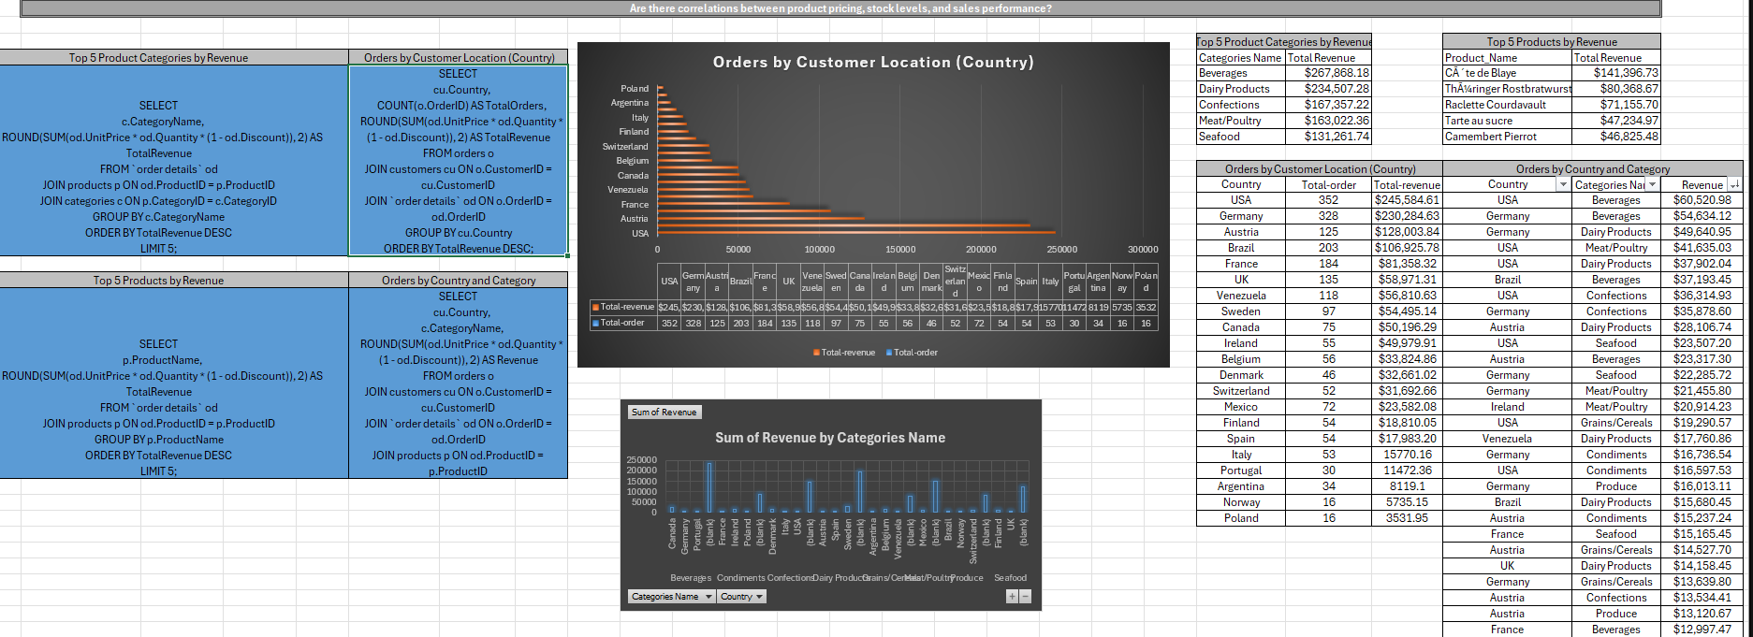

**Conclusion**

**. Top Revenue-Contributing Product Categories**

* **Beverages** generated the highest revenue, with **$267,868.18**.
* **Dairy Products** follow closely with **$234,507.28**.
* Other strong categories include **Confections**, **Meat/Poultry**, and **Seafood**.

**Conclusion:**  
Beverages and Dairy Products together make up nearly 40% of the total revenue. This shows they are in high demand and are very important for the business.

**2. Top Revenue-Generating Products**

* **Côte de Blaye** (a premium wine) earned the most with **$141,396.73**.
* **Thüringer Rostbratwurst** brought in **$80,368.67**.
* Other top products include **Raclette Courdavault**, **Tarte au sucre**, and **Camembert Pierrot**.

**Conclusion:**  
Côte de Blaye plays a major role in the Beverages category’s success. High-value or luxury products are popular with customers and generate strong revenue.

**3. Revenue by Customer Location (Top 5 Countries)**

| **Country** | **Orders** | **Revenue** |
| --- | --- | --- |
| USA | 352 | $245,584.61 |
| Germany | 328 | $230,284.63 |
| Austria | 125 | $128,003.84 |
| Brazil | 203 | $106,925.78 |
| France | 184 | $81,358.32 |

**Conclusion:**  
The **USA and Germany** lead in both the number of orders and total revenue. These are the most profitable markets and could be targeted more with marketing campaigns or exclusive offers.

**4. Product Category Preferences by Country**

* **USA:** Strong sales across all categories, especially **Beverages**, **Meat/Poultry**, and **Dairy**.
* **Germany:** Similar to the USA, with strong performance in **Beverages**, **Dairy**, and **Confections**.
* **Austria:** High demand for **Dairy** and **Beverages**.
* **Brazil:** Mostly purchases **Beverages**, followed by **Dairy** and **Seafood**.
* **France:** Performs well in **Seafood**, **Beverages**, and **Confections**.

**Conclusion:**  
Each country has its own product preferences. This information can be used for:

* Country-specific marketing
* Prioritizing stock based on location
* Adjusting prices according to demand

**5. Key Correlation Findings**

* Revenue is **strongly related to country-specific preferences** in product categories.
* **Beverages** are popular in nearly all countries.
* However, countries like **France and Sweden** show more interest in **Seafood** and **Produce**.

**Conclusion:**  
Where customers live affects what they buy. If product offerings match country preferences:

* Operations become more efficient
* Customer satisfaction increases
* Profits can go up

**10.How does product demand change over months or seasons?**

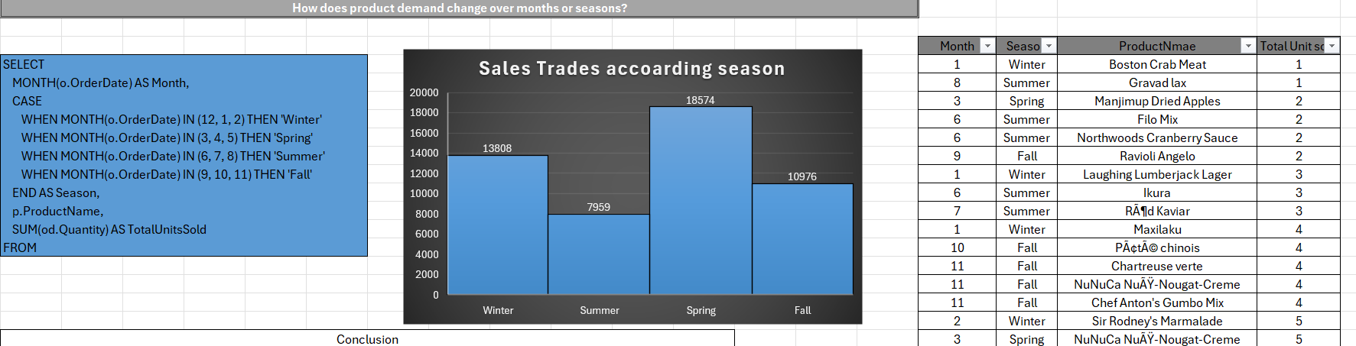

**Conclusion**

**Monthly Patterns:**

Products might see spikes in specific months, hinting at:

Holidays or end-of-year (e.g., November–December).

Summer dips or booms depending on product type.

**Product Category Influence:**

Beverages or seasonal foods may peak cyclically.

Staples (like bread, flour) show more stable demand.

**Inventory Planning:**

Products with seasonal demand need adjusted stock planning to avoid understocking or overstocking.

Helps identify off-season periods for promotions or discounts.

**11.Can we identify anomalies in product sales or revenue performance?**

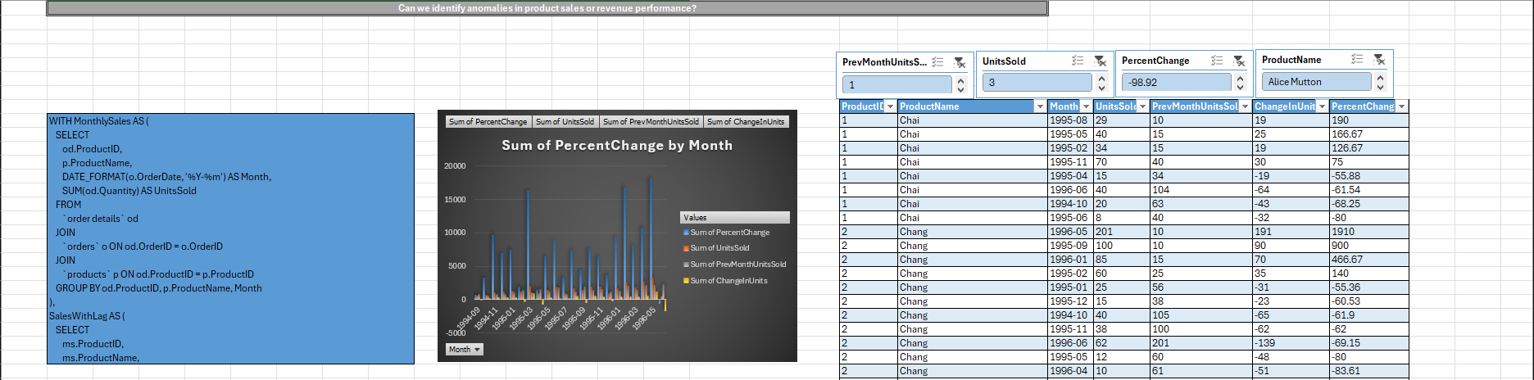

**1. Significant Sales Spikes Identified**

There were sharp increases in units sold in several months:

February 1995: +126.67%

May 1995: +166.67%

August 1995: +190.00%

November 1995: +75.00%

**Possible reasons:**

Promotional campaigns

Seasonal demand surge

New market/customer acquisition

Restocking after previous low supply

2**. Notable Drop in April 1995**

A significant drop of -55.88% occurred in April 1995 compared to March.

**Possible causes:**

Stockout or supply chain disruption

Seasonal dip in demand

Market shift or pricing change

Competitive influence

**3. Volatility in Sales**

"Chai" demonstrates high variability in month-over-month sales.

This suggests the need for better demand forecasting or more stable inventory planning.

**12. Are there any regional trends in supplier distribution and pricing?**

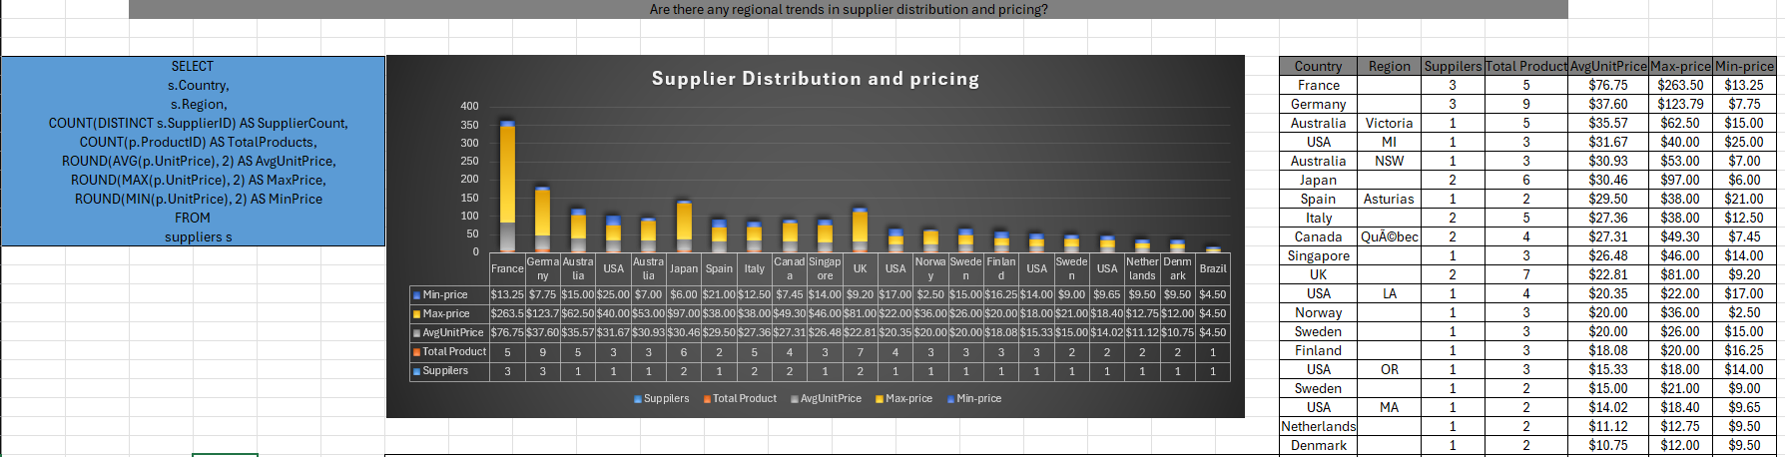

**Conclusion**

**France Leads in Premium Pricing**

France has the highest average unit price at $76.75 and an extremely high maximum price of $263.50.

Suggests France is a major source of premium or luxury products.

Despite having only 5 products, its high prices show strong per-unit value.

**2. Germany Offers High-Value Variety**

Germany has 3 suppliers and 9 products, showing broad product coverage.

With an average unit price of $37.60 and max of $123.79, Germany provides both mid-range and premium products.

**3. Asia-Pacific: Consistent but Mid-Priced**

Japan, Australia, Singapore, and New Zealand (not shown but relevant) have unit prices in the $26–36 range.

Suggests they export specialized, but not ultra-premium goods.

**4. USA Shows Diverse but Lower Pricing**

Multiple regions (MI, LA, MA, OR) with varying prices.

Average unit prices range from $14.02 to $31.67, showing a broad spectrum of product quality.

Indicates diversified supply — from low-cost to moderate premium items.

**5. UK is a Mid-Tier Exporter**

UK has 2 suppliers, 7 products, average price of $22.81, and max price of $81.00.

Sits in the mid-range — useful for general goods or groceries, but not high-end.

**6. Low-Cost Suppliers Concentrated in Few Countries**

Brazil ($4.50), Denmark ($10.75), Netherlands ($11.12) offer the lowest average unit prices.

Likely supply bulk or basic goods, possibly raw ingredients or staples.

**7. Anomalies and Outliers**

France’s $263.50 max price is a major outlier, more than 3x the next highest.

Suggests either:

A unique high-ticket item (e.g., specialty cheese, wine),

Or potential pricing error needing audit.

**13. How are suppliers distributed across different product categories?**

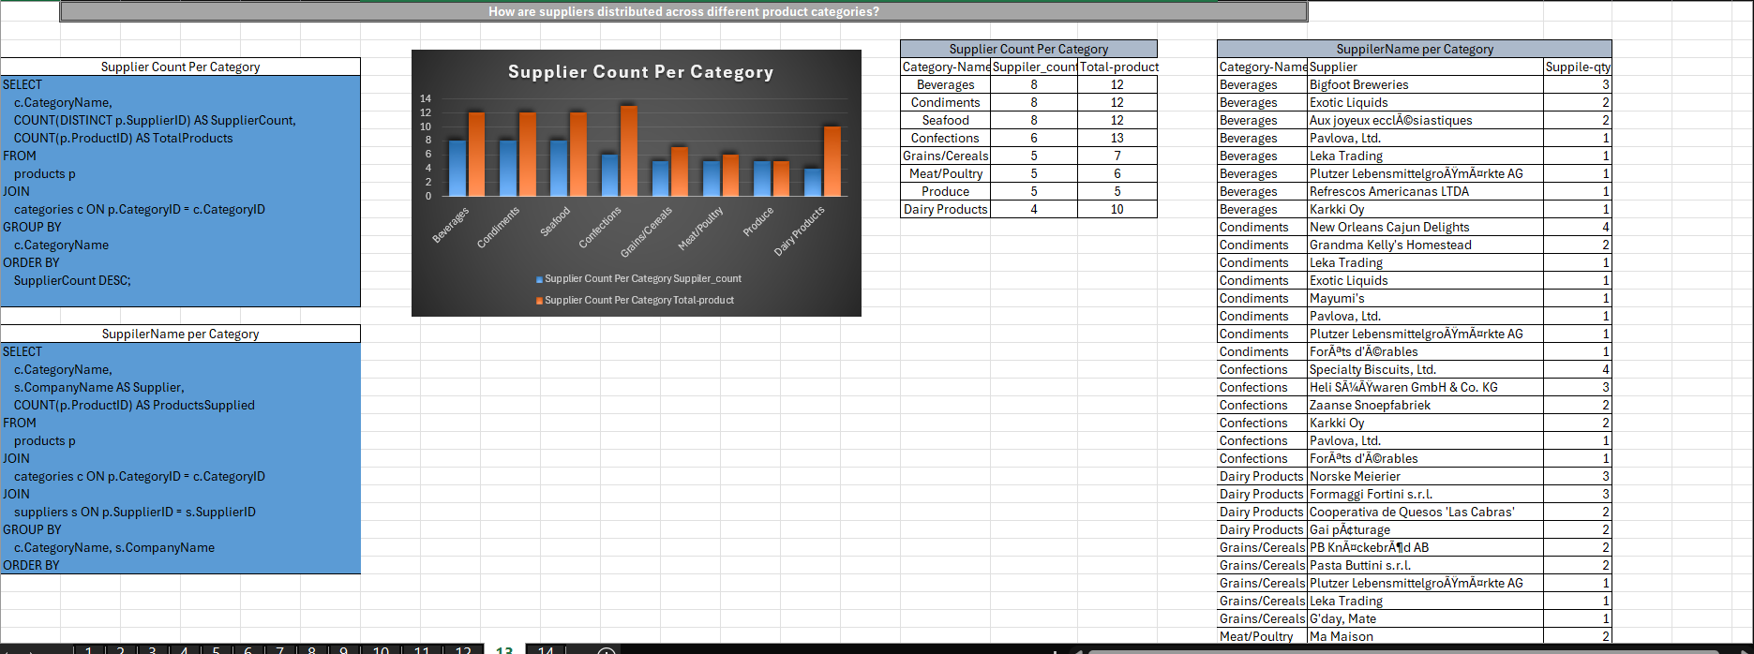

**1. Beverages and Condiments Dominate in Supplier Diversity**

Beverages and Condiments each have 8 unique suppliers — the highest of any category.

These categories are likely core product lines with high demand and wider sourcing optons.

Supplier overlap also exists (e.g., Exotic Liquids, Plutzer Lebensmittelgroßmärkte AG supply both categories).

**2. Confections Has Moderate Diversity but High Product Count**

With 6 suppliers and 13 products, Confections has the highest product count per supplier (~2.2 products/supplier).

Suggests deeper specialization per supplier (e.g., Specialty Biscuits, Ltd. supplies 4 confectionery items).

**3. Grains/Cereals and Meat/Poultry Have Narrower Supplier Bases**

Both have 5 suppliers, but fewer products (7 and 6 respectively).

Suppliers like Leka Trading and Plutzer Lebensmittelgroßmärkte AG appear across multiple categories — possibly indicating multi-category providers or distributors.

**4. Produce Is the Most Concentrated**

5 suppliers for only 5 products, with each supplier offering exactly one item.

Indicates that produce supply is fragmented, possibly due to perishability, seasonal variation, or local sourcing constraints. **5. Dairy Products Are Specialized**

4 suppliers cover 10 dairy products, averaging 2.5 products per supplier.

Key suppliers (e.g., Formaggi Fortini s.r.l., Norske Meierier) provide multiple items, indicating regional dairy specialists.

**6. Seafood Shows Supplier Parity with Balanced Product Coverage**

8 suppliers for 12 products — like beverages and condiments.

Some suppliers (e.g., Svensk Sjöföda AB) are leading contributors, while others only provide 1 item.

**7. Cross-Category Suppliers Are Common**

Suppliers like:- Plutzer Lebensmittelgroßmärkte AG — active in Condiments, Beverages, Grains, Produce, MeatPavlova, Ltd. — contributes to Beverages, Condiments, Confections, Meat, Seafood

**14. How do supplier pricing and categories relate across different regions?**

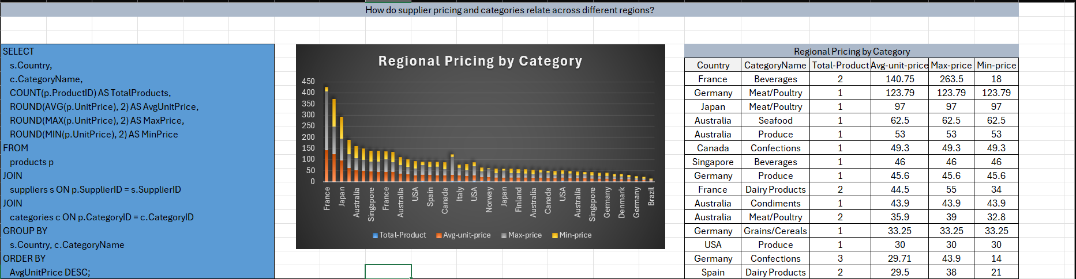

**1. France and Germany Sell Expensive Products**

* **France** has the most expensive products, especially in **drinks** (average price: $140.75, maximum: $263.50).
* **Germany** also sells costly items like **meat, vegetables, and sweets** (e.g., meat at $123.79).
* These two countries mainly sell **high-quality, luxury, or branded items**.

**2. Japan and Australia Have Medium to High Prices**

* **Japan** sells **meat** (avg. $97) and **seafood** ($18.5–$31) at higher prices.
* **Australia** prices are also higher in **seafood ($62.5)**, **condiments ($43.9)**, and **produce ($53)**.
* These prices suggest **special or organic quality products**.

**3. Brazil, Denmark, and Netherlands Are Cheaper**

* **Brazil** has the **cheapest drinks** at only **$4.50**.
* **Denmark** and **Netherlands** offer low prices for **seafood ($10.75)** and **sweets ($11.12)**.
* These countries focus on **cheap and bulk products**, not luxury ones.

**4. USA Sells Both Cheap and Mid-Price Items**

* **Condiments ($24.4)** and **seafood ($14.02)** are medium priced.
* **Drinks and produce** are generally cheaper.
* The USA sells **both affordable and specialty products**, targeting all types of customers.

**5. Dairy Prices Are Different in Each Country**

| **Country** | **Average Dairy Price** |
| --- | --- |
| France | $44.50 |
| Spain | $29.50 |
| Italy | $26.43 |
| Norway | $20.00 |

* **France** sells more **fancy or special dairy**, like artisan cheese.
* Other countries offer **basic and cheaper dairy products**.

**6. Grains and Cereals Are Always Cheap**

* In countries like **Germany, Italy, Sweden, Singapore, and Australia**, grains cost less than **$33**.
* These are usually **everyday, affordable food items**.

**7. Top Countries in Multiple Categories**

* **Germany** ranks high in **more than 5 product types**.
* **Australia and France** also do well in many areas with high prices.
* These countries are **strong suppliers** with **many premium-quality products**.

**Power BI**

**Visualization**

**Relationship Table**

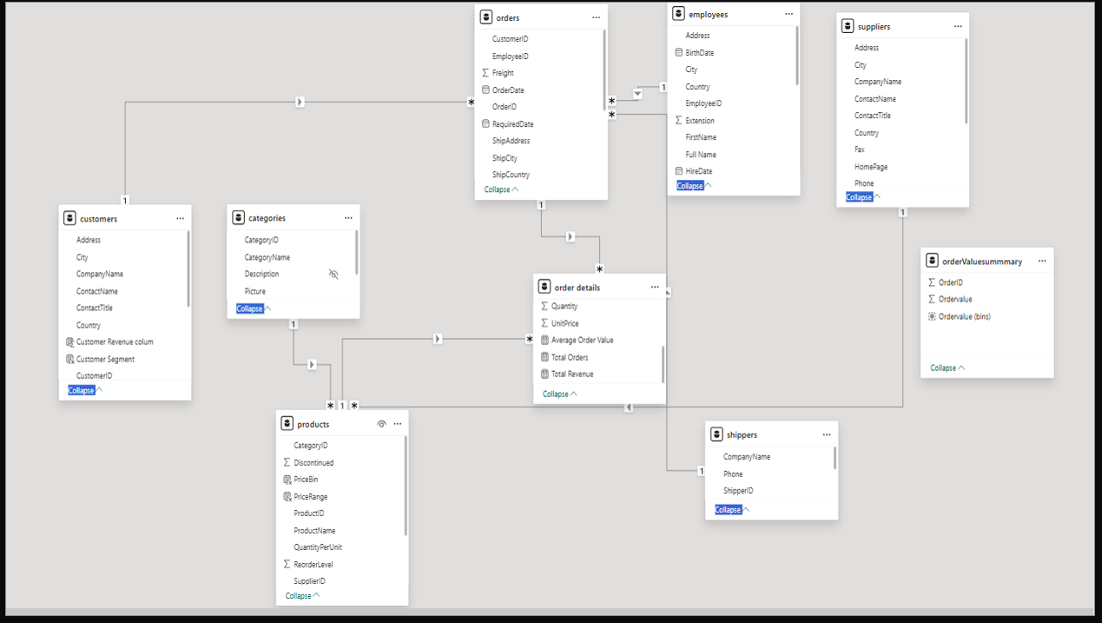

1. customers → orders

* Relationship: One-to-Many (1:*)
* Key Field: CustomerID
* Purpose: Links customers to their corresponding orders.
* Insight: Allows analysis of orders by customer details like country, segment, or revenue.

2. employees → orders

* Relationship: One-to-Many (1:*)
* Key Field: EmployeeID
* Purpose: Maps each order to the employee responsible for it.
* Insight: Enables performance analysis by employee or tracking orders handled by staff.

3. orders → order details

* Relationship: One-to-Many (1:*)
* Key Field: OrderID
* Purpose: Breaks down each order into individual products and their quantities.
* Insight: Enables calculation of revenue, average order value, and product-level sales.\

4. order details → products

* Relationship: Many-to-One (*:1)
* Key Field: ProductID
* Purpose: Associates each order item with a product.
* Insight: Supports product-level analysis—e.g., which products are top-selling.

5. products → categories

* Relationship: Many-to-One (*:1)
* Key Field: CategoryID
* Purpose: Groups products into broader categories.
* Insight: Enables category-based revenue analysis (e.g., Beverages, Dairy).

6. orders → shippers

* Relationship: Many-to-One (*:1)
* Key Field: ShipperID
* Purpose: Connects each order with the shipping company used.
* Insight: Helps evaluate shipping performance or cost analysis per shipper.

7. products → suppliers

* Relationship: Many-to-One (*:1)
* Key Field: SupplierID
* Purpose: Links each product to the supplier that provides it.
* Insight: Useful for supplier performance, cost analysis, and sourcing insights.

8. orders → orderValuesummary

* Relationship: One-to-One (1:1)
* Key Field: OrderID
* Purpose: Adds pre-aggregated or calculated order value bins for segmentation.
* Insight: Used for analysis by order value ranges (e.g., low, medium, high value orders).

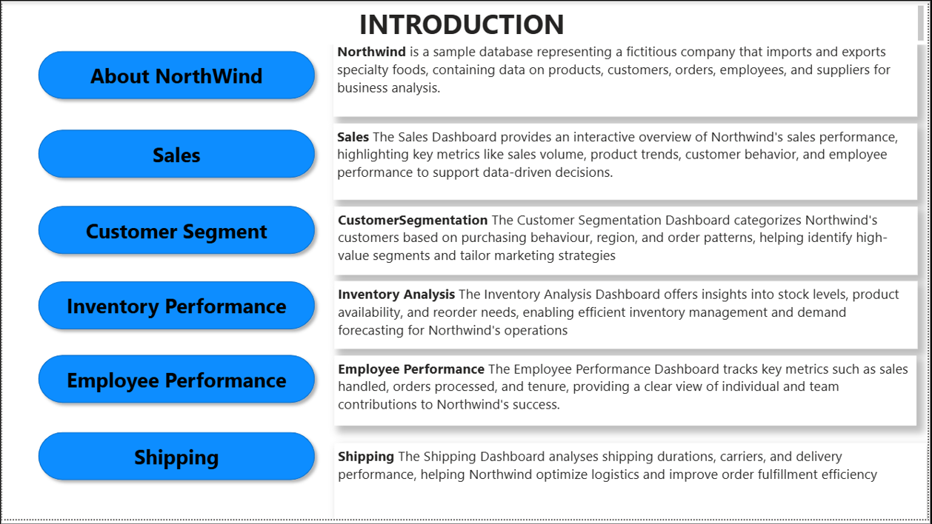

**Sales Dashboard Overview**

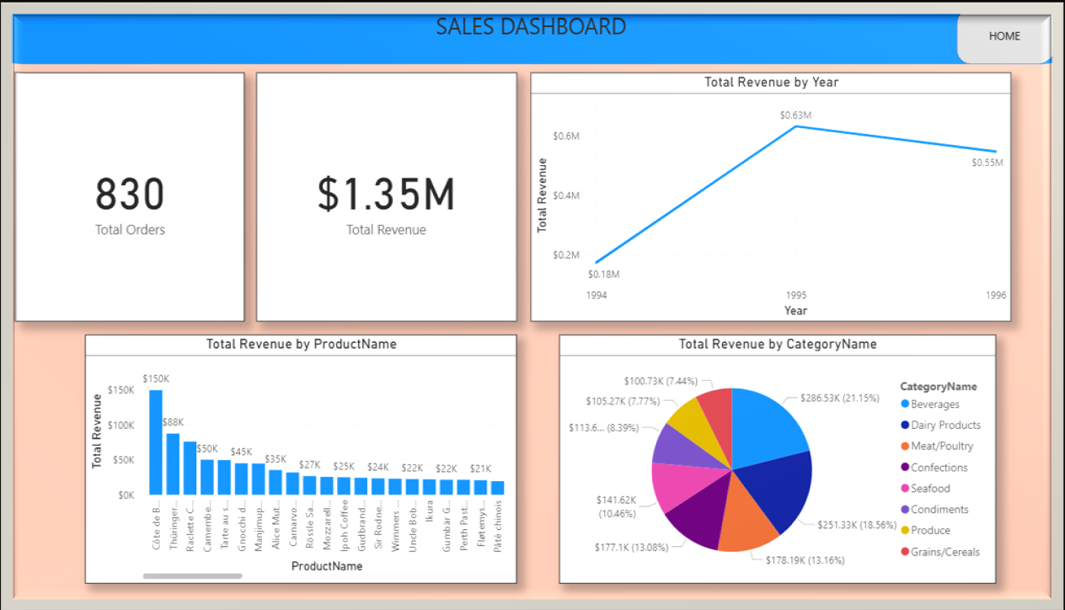

This interactive Sales Dashboard gives a clear view of total business performance by combining KPIs, product performance, yearly trends, and category-level analysis.

Key Metrics

* Total Orders: 830  
  Indicates strong customer engagement and order volume.
* Total Revenue: $1.35M  
  Reflects the total value generated across all orders—suggesting a healthy revenue base.

Revenue Trend: Total Revenue by Year

* 1994: ~$0.18M
* 1995: Peaks at ~$0.63M
* 1996: Slight drop to ~$0.55M

**Insight**:  
Revenue increased significantly from 1994 to 1995, then slightly declined in 1996. This suggests a peak performance year in 1995, potentially due to successful product launches, marketing campaigns, or new customer acquisition.

Product-Level Insights: Total Revenue by Product Name

* Top Product: *Côte de Blaye* (~$150K)
* Other high performers include:
  + *Thüringer Rostbratwurst* (~$88K)
  + *Raclette Courdavault* (~$50K)
  + *Camembert Pierrot*, *Tarte au sucre*, etc.

**Insight:**  
Revenue is skewed toward a few top-performing products, especially premium ones like wines and specialty meats/cheeses. These likely drive customer loyalty and profit margins.

Category Insights: Total Revenue by Category Name

* Top Categories:
  + Beverages – $286.53K (21.15%)
  + Dairy Products – $251.33K (18.56%)
  + Meat/Poultry – $178.19K (13.16%)

**Insight:**

* Beverages and Dairy dominate revenue contribution.
* Categories like Condiments, Seafood, and Confections also contribute meaningfully.
* Indicates customer demand is broadly distributed, but with clear leaders.

**Conclusion**

* The business is performing well, with a revenue peak in 1995.
* Top products and categories like beverages and dairy are critical to revenue success.
* Monitoring trends in 1996 and beyond is essential to reverse any declines.
* High-performing premium products should be prioritized in inventory and marketing strategy.

**Customer Segment Dashboard Summary**

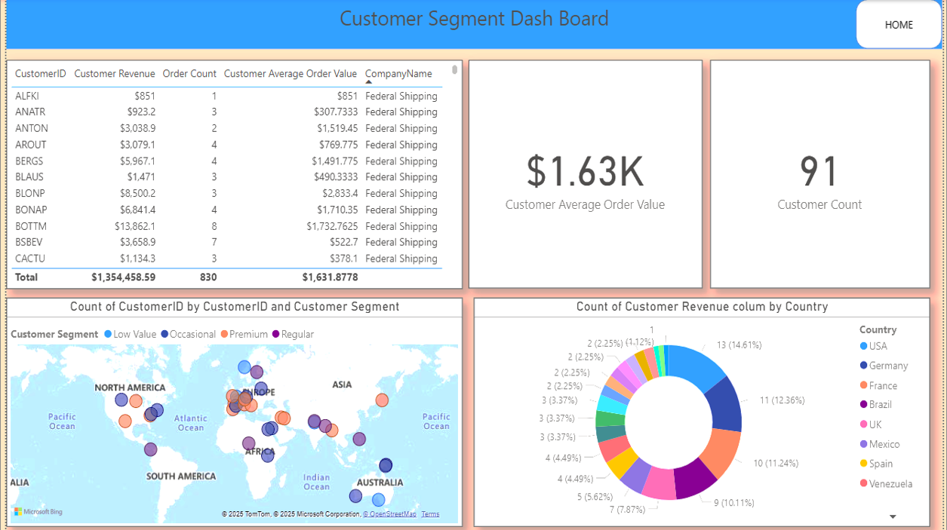

This dashboard offers a deep dive into customer behavior, segmentation, and revenue contribution, helping identify high-value customers, order trends, and country-wise distribution.

Key Metrics

* Total Revenue: $1.35M
* Total Orders: 830
* Customer Count: 91
* Average Order Value per Customer: $1,631.88

These values indicate a strong and diversified customer base, with significant repeat purchasing behavior.

Top Customer Insights

From the customer table (top-left):

* Top Customers by Revenue:
  + BOTT – $13,862.10 (8 orders)
  + BLONP – $8,500.20 (3 orders)
  + BSBEV – $3,658.90 (7 orders)
  + BONAP – $6,841.40 (4 orders)
* Highest Average Order Values:
  + ANTON – $1,519.45
  + BONAP – $1,710.35
  + BOTT – $1,732.76

**Insight:**

High-value repeat customers like BOTT and BONAP contribute significantly to total revenue. These customers are ideal candidates for loyalty programs or exclusive deals.

Customer Distribution by Segment (Map)

* Customer segments include:
  + Low Value
  + Occasional
  + Regular
  + Premium
* Segments are spread globally, with key clusters in:
  + North America
  + Europe
  + Australia
  + Select regions in Asia and Africa

**Insight:**

The global spread of premium and regular customers suggests strong international market penetration. Region-specific campaigns can further boost loyalty.

Customer Count by Country (Pie Chart)

Top countries by customer count:

* USA (14.6%)
* Germany (12.36%)
* France (11.24%)
* Brazil (10.11%)
* UK (7.87%)
* Mexico (5.62%)

**Insight:**  
The USA, Germany, and France dominate the customer base. Tailored promotions for these regions can yield higher engagement and retention.

**Inventory Analysis Dashboard Summary**

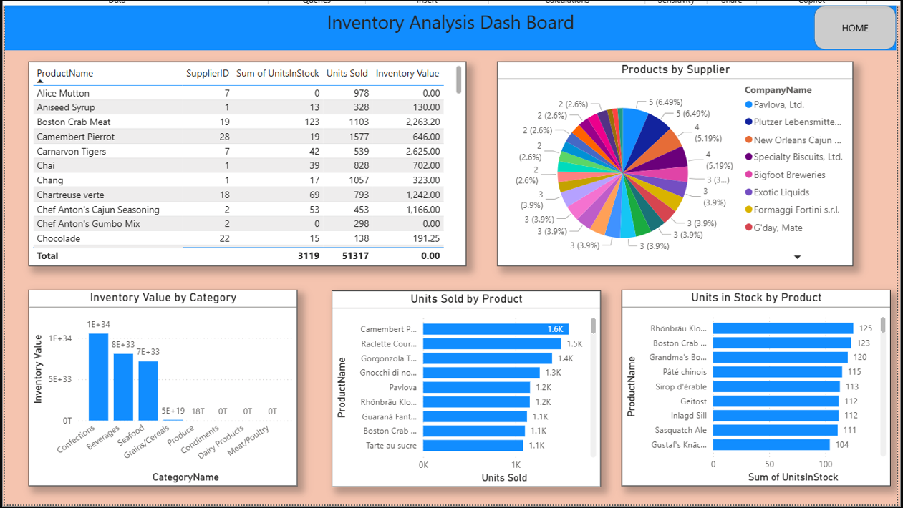

This dashboard provides critical insights into stock levels, product movement, supplier contributions, and category-level inventory trends. It enables efficient supply chain planning and helps reduce stockouts or overstocking.

Key Metrics Overview

* Total Units in Stock: 3,119
* Total Units Sold: 51,317
* Total Inventory Value: 0.00 *(Note: Likely a data issue or field miscalculation—should be verified.)*

Top Performing Products (Units Sold)

| Product Name | Units Sold |
| --- | --- |
| Camembert Pierrot | 1.6K |
| Raclette Courdavault | 1.5K |
| Gorgonzola Telino | 1.4K |
| Gnocchi di nonna Alice | 1.3K |
| Pavlova | 1.2K |
| Rhönbräu Klosterbier | 1.2K |

**Insight:**  
These are fast-moving items. Special attention should be given to stock replenishment and forecast accuracy to meet continued demand.

Top Inventory on Hand (Units In Stock)

| **Product Name** | **Units in Stock** |
| --- | --- |
| Rhönbräu Klosterbier | 125 |
| Boston Crab Meat | 123 |
| Grandma’s Boysenberry | 120 |
| Pâté chinois | 115 |
| Sirop d’érable | 113 |

**Insight:**  
These products may be overstocked or moving slower. Consider promotional strategies or deeper stock analysis.

**Inventory Value by Category**

Top categories by inventory value (note: scale values may be exaggerated due to data format):

* Beverages
* Seafood
* Grains/Cereals
* Confections

**Insight:**  
High inventory value in Beverages and Seafood suggests these are premium categories or stored in bulk. Ensure alignment between stock levels and sales velocity.

Products by Supplier

* Diverse Supplier Base: Most suppliers contribute a small percentage (2.6–6.5%) of products.
* Top Suppliers: Pavlova Ltd., Plutzer Lebensmittelgroßmärkte AG, Specialty Biscuits Ltd., and more.

**Insight:**  
A balanced supplier portfolio reduces dependency risks. But consolidation might improve procurement efficiency and costs.

Product-Level Observations (Table Overview)

* Camembert Pierrot (ProductID 28):
  + Units Sold: 1,577
  + Units In Stock: 19
* Boston Crab Meat (ProductID 19):
  + Units Sold: 1,103
  + Units In Stock: 123

**Insight:**  
These products show strong performance. Low stock with high sales suggests they may need stock optimization or faster restocking cycles.

**Employee Performance Dashboard Summary**

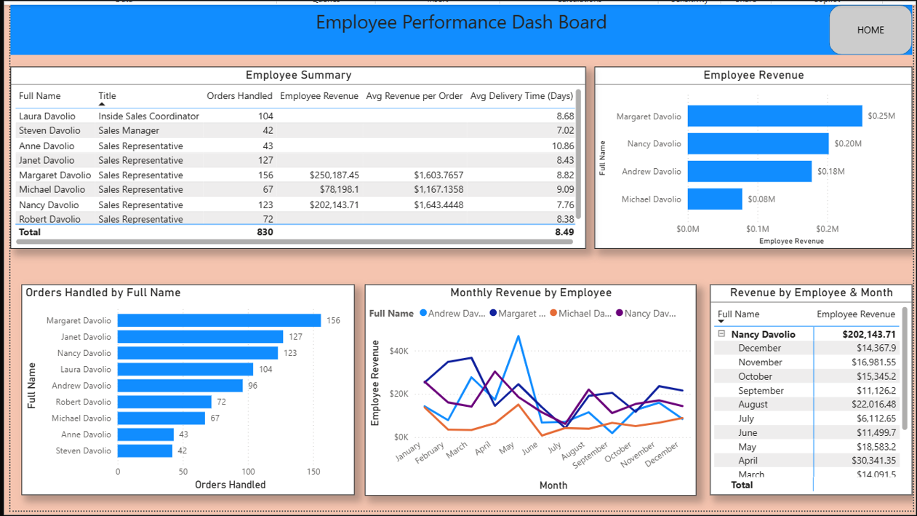

This dashboard offers an in-depth view of individual employee performance based on orders handled, revenue generated, and average delivery times. It enables performance tracking, highlights top performers, and supports data-driven team management.

Key Metrics (From Summary Table)

| **Metric** | **Value** |
| --- | --- |
| Total Orders | 830 |
| Average Delivery Time | 8.49 days |
| Top Performer (Revenue) | Margaret Davolio ($250K) |
| Top Performer (Orders) | Margaret Davolio (156 orders) |

Top Employees by Revenue

| Employee | Revenue | Avg Revenue/Order | Orders |
| --- | --- | --- | --- |
| Margaret Davolio | $250,187.45 | $1,603.77 | 156 |
| Nancy Davolio | $202,143.71 | $1,643.44 | 123 |
| Andrew Davolio | $184,654.00* (approx) | $1923.47 | 96 |
| Michael Davolio | $78,198.10 | $1,167.13 | 67 |

**Insight:**Both Margaret and Nancy have high revenue and order volume, making them key revenue drivers. Nancy also has the highest revenue per order.

Top Employees by Orders Handled

| Employee | Orders |
| --- | --- |
| Margaret Davolio | 156 |
| Janet Davolio | 127 |
| Nancy Davolio | 123 |
| Laura Davolio | 104 |

**Insight:**  
These employees are managing large workloads efficiently. Janet and Laura, though not top in revenue, are essential in volume handling.

**Monthly Revenue Trend**

* Nancy Davolio peaked in April ($30K+) and July ($26K).
* Revenue trends show seasonality, with dips in mid-year and spikes in spring/winter.

**Insight:**  
Nancy has strong performance across months, indicating consistent client engagement. Others show variable revenue patterns.

**Delivery Time Performance**

| Employee | Avg Delivery Time (days) |
| --- | --- |
| Steven Davolio | 7.02 (fastest) |
| Nancy Davolio | 7.76 |
| Margaret Davolio | 8.82 |
| Michael Davolio | 9.09 |
| Anne Davolio | 10.86 (slowest) |

**Insight**:  
Steven and Nancy ensure faster deliveries, which may boost customer satisfaction. Anne’s longer delivery time may warrant further review.

Overall Observations

* Margaret Davolio is the overall top performer in terms of revenue and volume.
* Nancy Davolio excels in order value efficiency and consistent monthly performance.
* Some employees (like Anne & Steven) handle fewer orders but may be new or in supporting roles.
* The team averages around 8.5 days for delivery, which is acceptable but can be optimized further.

**Shipping Dashboard Summary**

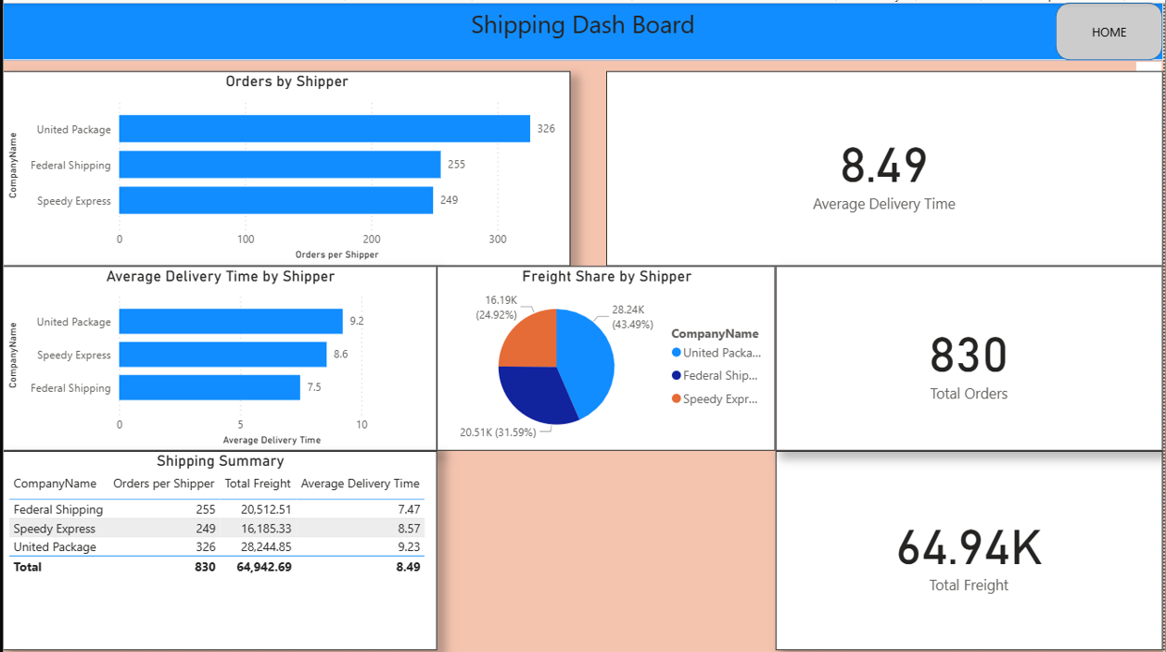

This dashboard provides a comprehensive view of shipping operations, analyzing performance by shipper, delivery time, and freight cost. It highlights the most efficient and cost-effective delivery partners.

Key Metrics Overview

|  |  |
| --- | --- |
| Metric | Value |
| Total Orders | 830 |
| Total Freight | $64,942.69 |
| Average Delivery Time | 8.49 days |

**Orders by Shipper**

United Package handled the highest number of shipments (39% of total), followed by Federal Shipping and Speedy Express.

**Average Delivery Time by Shipper**

Federal Shipping is the fastest delivery partner, while United Package takes nearly 2 days longer on average.

**Freight Cost Distribution**

United Package has the highest freight cost and slowest delivery, despite managing the most shipments. Evaluation of its cost-efficiency is advised.

**Performance Summary**

A detailed comparison of orders, freight cost, and delivery time across all shippers:

|  |  |  |  |
| --- | --- | --- | --- |
| Company | Orders | Freight | Avg Delivery Time |
| Federal Shipping | 255 | $20,512.51 | 7.47 days |
| Speedy Express | 249 | $16,185.33 | 8.57 days |
| United Package | 326 | $28,244.85 | 9.23 days |
| Total | 830 | $64,942.69 | 8.49 days |

